### Components of Micro-Service

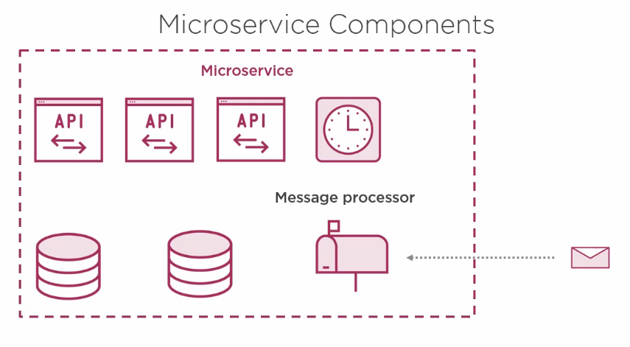1. APIs

2. Databases

3. Scheduled Tasks

4. Messaging Queue/Processor

etc...